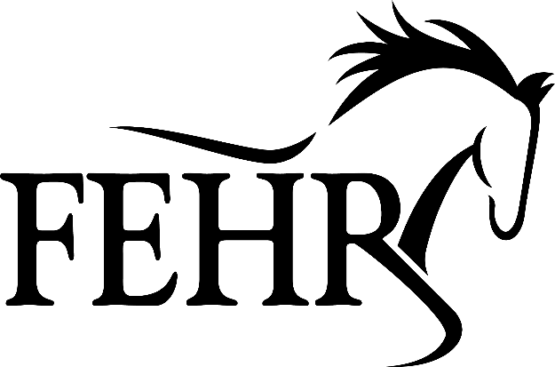
GIFT CERTIFICATE
TO:__________________________________________________
FROM:_______________________________________________
This certificate has a cash value of $_________________, it may be used towards the cost of facility rentals, horse board,
FEHR provided - lessons, camps, clinics, training.

We offer -horsemanship -partnership training -riding lessons -clinics -trail rides -summer camps -and more.

